If you work in IT you will have these working options:
- Office work
- Remote work (WFH)
- Hybrid work
- Relocation
1. a) Read and decide how these people work. (in office, remote, hybrid or plan relocation)
- Anna: Every day I wake up at 7 am. I have breakfast and get dressed. Then I take my bag with my laptop and go outside. I drive 30 minutes to my workplace. When I arrive I go to the kitchen and drink coffee with my co-workers. - ……
- Steve: I work for a middle-sized IT company as a designer. My company has a small office in my town, so I go to the office 2 or 3 times per week when I have important meetings and discussions with my team. The rest of the time I work from my house……
- Paul: I wake up at 9 am. I drink my coffee and go running. After the run, I take a shower, have breakfast, and open my laptop. I check my email and start my working day. At 6 I close my laptop and turn on my TV)........
- Natalie: I got a job at this big popular company and they have a nice office in London. I live in Liverpool but I need to come to the office every day, so I decided to move to London because I really want to work at this company……
b) Answer the questions:
1. How long is Anna’s commute?
2. Where does Natalie plan to relocate?
3. Why does Steve go to the office?
4. When does Paul finish his work?
c) Fill in the gaps in the text.
“Every day I wake up at 7 am. I have breakfast and ….. dressed. Then I take my bag with my…… and go outside. I drive 30 minutes to my ……. When I arrive I go to the kitchen and drink coffee with my ………”.
“Natalie: I ……. a job at this big popular company and they have a nice office in London. I live in Liverpool but I need to come to the …….. every day, so I decided to……… to London because I really want to work at this company……”
Use these texts to talk about your working day.
Tell about your commute, workplace, working hours, etc.
d) Tick the reasons why Steve comes to the office.
Steve: I work for a middle-sized IT company as a designer. My company has a small office in my town, so I go to the office 2 or 3 times per week when I have important meetings and discussions with my team. The rest of the time I work from my house…
Office parties
better meetings
lunch together
faster communication
2. a) Decide which adjectives can be used to describe these items. Put the adjective into the correct column of the table. You don’t need to use all adjectives.
“ Light, Efficient, Long, Wide, Heavy, Fast, Dark, Soft, Hard, Durable, Expensive, Stylish, Crowded”
Laptop/PC | Chair | Headphones | Office | Monitor
 | Soft

b) Make comparatives and superlatives from these words:
ex. Light-Lighter-the lightest
1) Light -
2) Efficient -
3) Long -
4) Wide -
5) Heavy -
6) Fast -
7) Dark -
8) Soft -
9) Hard -
10) Durable -
Grammar Note!!!
We usually add –er and –est to one-syllable words to make comparatives and superlatives:
small - smaller- the smallest
If an adjective ends in –e, we add –r or –st:
large - larger - the largest
If an adjective ends in a vowel and a consonant, we double the consonant:
big - bigger- the biggest
If an adjective ends in a consonant and –y, we change –y to –i and add –er or –est:
dirty- dirtier - the dirtiest
We use more and most to make comparatives and superlatives for most two-syllable adjectives and for all adjectives with three or more syllables:
friendly - more friendly - the most friendly
The adjectives good, bad and far have irregular comparatives and superlatives:
good- better- the best
bad- worse - the worst
far- further/farther- the furthest/farthest
little - less- the least

3. Complete the sentences by putting the word in brackets into the correct form.
ex. Laptop A costs 1000$ and laptop B costs 2000$. Laptop A is cheaper (cheap) than laptop B.
1. Mouse A weighs 200 g and mouse B weighs 300 g. Mouse B is ……(heavy) than mouse A.
2. I can use this laptop’s battery for 12 hours. This battery is ……………..(durable) I have ever had.
3. I can sit in this chair for 8 and more hours. This is ……….(soft) chair I have ever had.
4. My laptop weighs only 1.5 kg. It is ……… (light) than your laptop.
5. I really want to buy these headphones but they cost 100$. They are ……(expensive) headphones in this store.
6. He can do a lot of work during the day. He is ……… (efficient) than his co-workers.

4. Look at the pictures below and compare 2 offices., Use adjectives: big, small, light, dark, cosy, comfortable, modern, spacious, motivating etc.
ex. Google Office is darker than Facebook Office.

Facebook Office Google Office
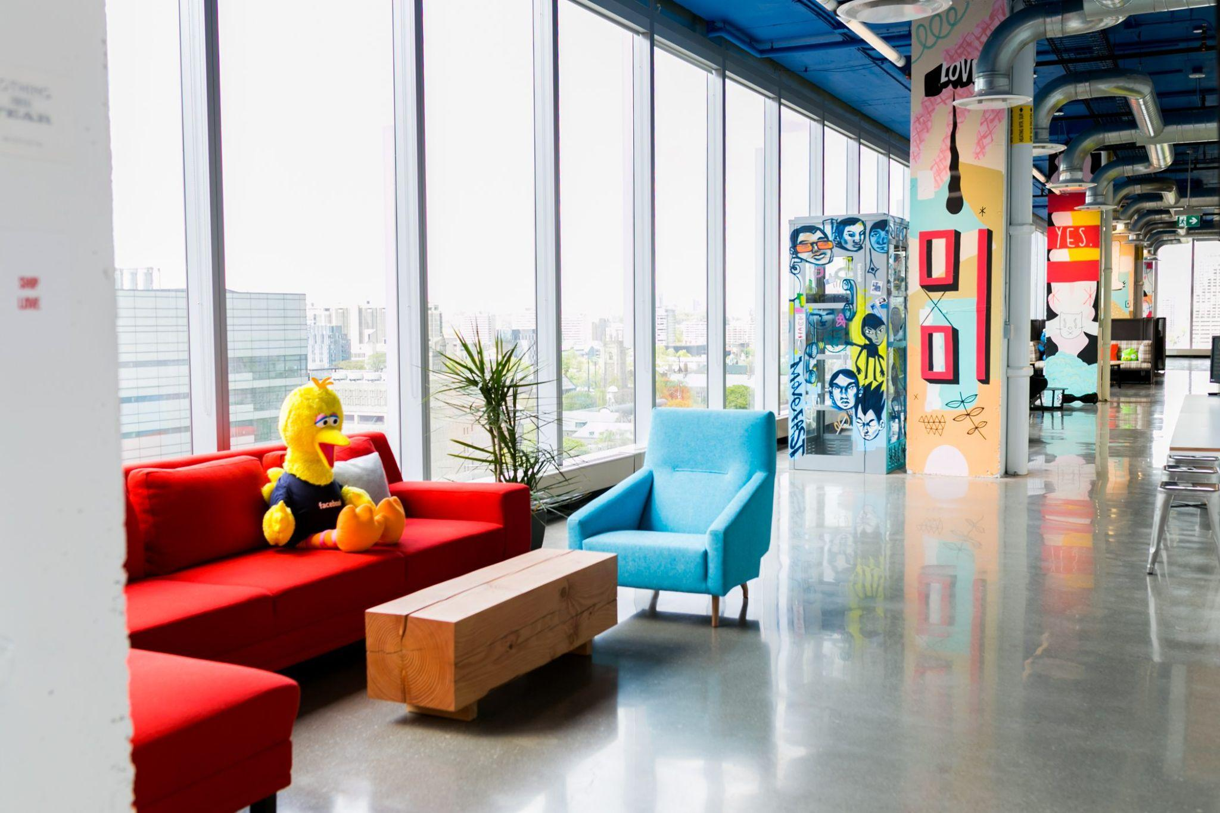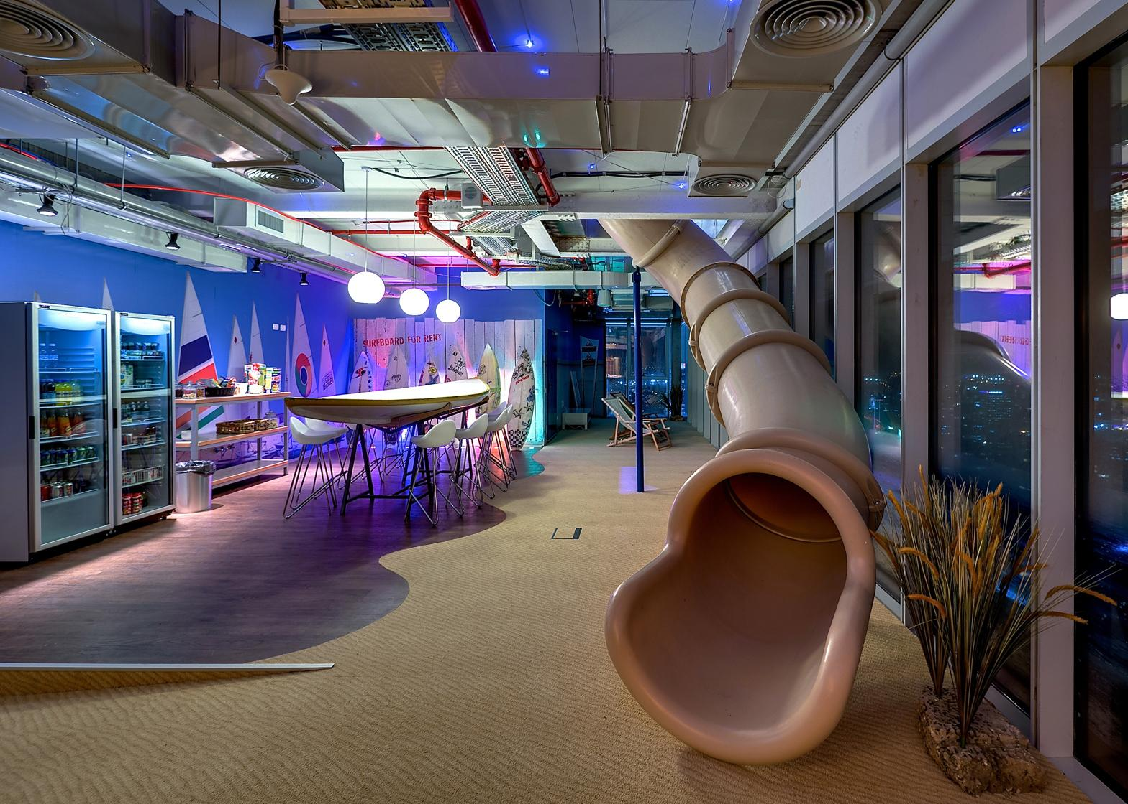

5. Watch the video about the Facebook office in London. Do you like it?
Would you like to work in an office like this?
Exclusive Look Inside Facebook’s Engineering Office In London

- Decide if the sentences below are True or False.

- The Facebook office has seven different floors
- There are 45 teams working in this office.
- The office was opened in 2016.
- Facebook offices' ceilings are unfinished by accident.
- Many of the rooms on the 3rd floor are named after Game of Thrones characters.
- Facebook employees don’t have to pay for their food in the office.

